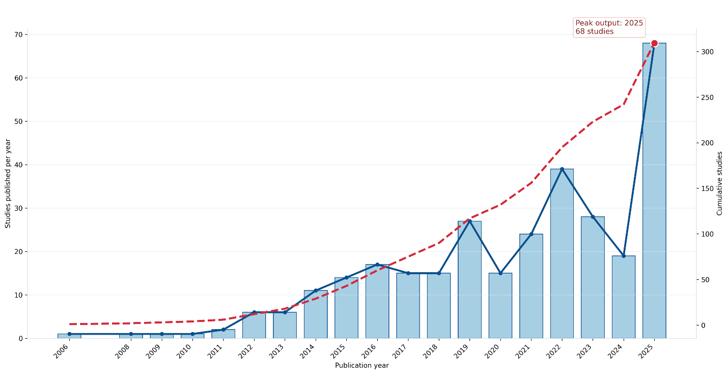
Figure 3. Publication trends and collaboration network (2000-2025). The bar graph shows the exponential research volume, with the highest number of 68 studies being conducted in the year 2025.

